**Tips for Navigating your MyOasis Dashboard**

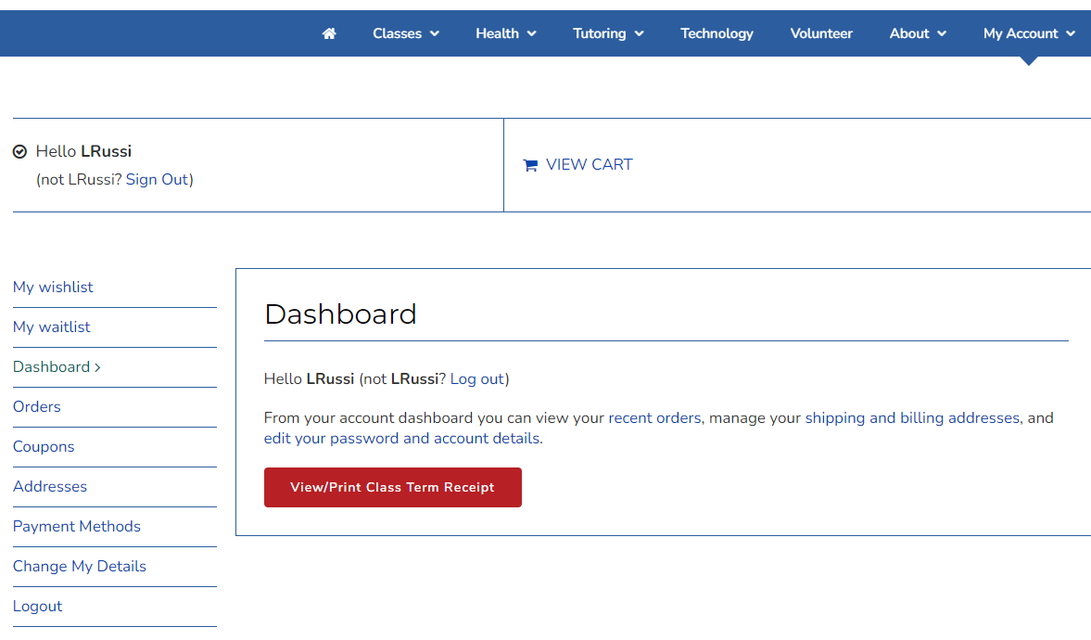

Click **Coupons** to view available coupons or credits. Note: A coupon or credit will not show up in your shopping cart if there are no classes in your cart.

Click **Orders** to see your past class registrations. From here you can view each order along with class details and Zoom links.

Click **My Account** to sign in and view your Dashboard.

Click **Classes** to go to the class listing page where you can search for classes and add them to your cart.

**Tips for Navigating the Oasis Class Search Page**

Use these buttons to view the class listing in a single or double column.

Use this button to switch your screen to a high contrast view.

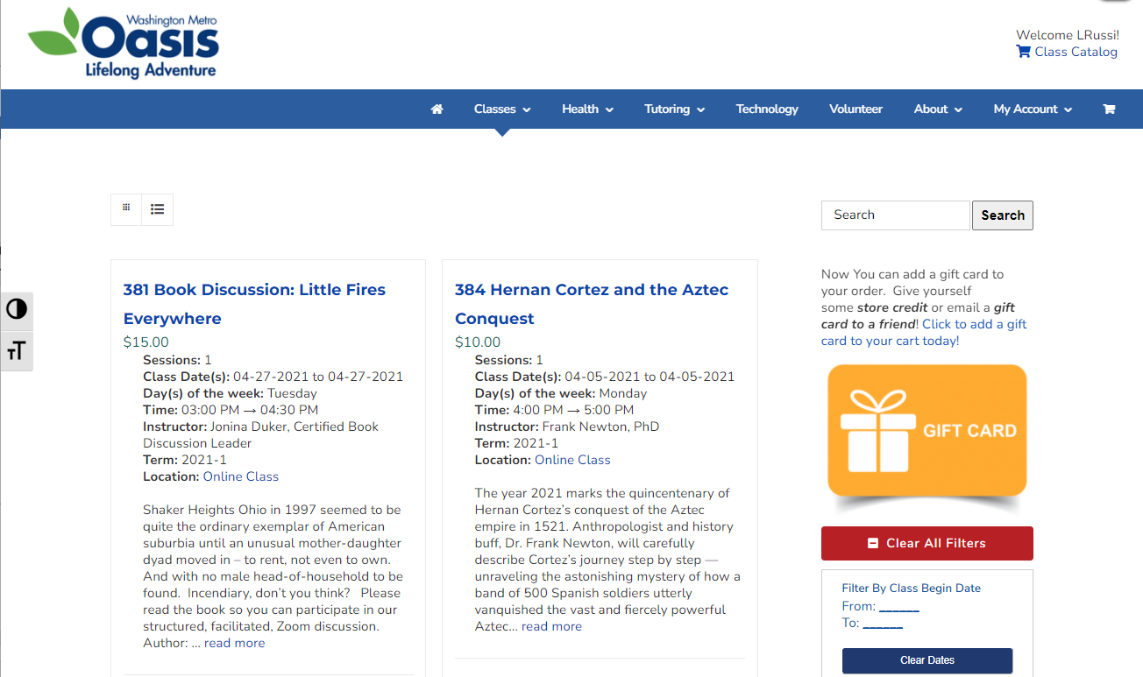

Click the cart icon to view your shopping cart.

Use this button to increase the font size on your screen.

**Tips for Navigating the Oasis Class Search Page (cont.)**

*Class filters are located in a single column on the right side of the class search page.*

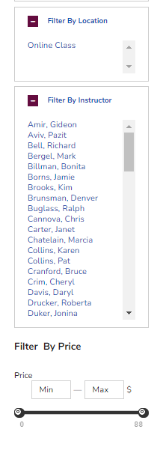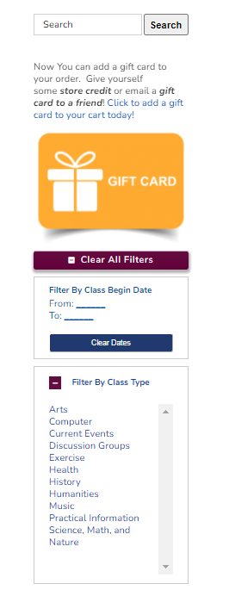

Type a class number, keyword or title here to search for a specific class.

Use these filters to search for classes by date, class type, location, instructor and price.